**Chapter 6**

**Database Design  
6.1 Introduction**

The database is the combination of some data that is processed and organized in such a way, to obtain a connection or relation between the data and can be used jointly by multiple users applications. In a simple, database (the database) can be expressed as organizing data with the help of computers that allows data to be accessed easily and quickly. In this case, the definition of access can include data acquisition and manipulation of data such as adding and deleting data. Benefits of databases in general, among others:

As a principal or an important component in the system information, because it is the basis for providing information.

➢ Determining the quality of information quickly, accurately, and relevant, so that the information presented is always updated. Information can be said to be worth when it benefits more than the cost to obtain.

➢ Overcoming duplicate data (data redundancy)

➢ Avoid any data inconsistencies

➢ Overcoming difficulties in accessing data

➢ Develop a standard format of data.

➢.The use of multiple users (multiple users). A database can be used at once is shared by many users (multiuser).

In the fast development of information technology, it’s time for an organization or company whether small, medium and large scale use of information systems based on the database to help its operations. With a good database system of an organization will be able to manage and monitor operational activities so they can take quick and appropriate steps if a problem occurs. So a good database system would bring rapid progress in the organization or a company.

6.2 **Database design for Bangladesh Livestock Research Institute (BLRI):**

Bangladesh Livestock Research Institute has a lot of projects. A good number of people researches and works in these projects. So, we need a database for storing all the important information to run this institute. So, we designed a database which will store information for all the employees, projects, trainees of the organization. The name of the database is BLRI database.

**6.2.1 ER diagram Design:**

The ER diagram defines the conceptual view of a database. It works around real-world entities and the associations among them. At view level, the ER diagram is considered a good option for designing databases. Any object, for example, entities, attributes of an entity, relationship

sets, and attributes of relationship sets, can be represented with the help of an ER diagram.

Entities are represented by means of rectangles. Rectangles are named with the entity set they

represent. Attributes are the properties of entities. Attributes are represented by means of

ellipses. Every ellipse represents one attribute and is directly connected to its entity (rectangle).

Our designed database can be represented by means of three ER diagram. One is for all the employees another is for the ongoing research, training and development projects and the other is for managing the trainees. The first ER diagram represents the employee management system. Three entities are connected in this system named Employees, Salaries, projects. The Employees entity has eight attributes while the other two has four attributes each. The entities are connected with a one-to-one relationship. Figure 6.1 shows the ER diagram for the employee management system. Salary has nine attributes and projects has five attributes.

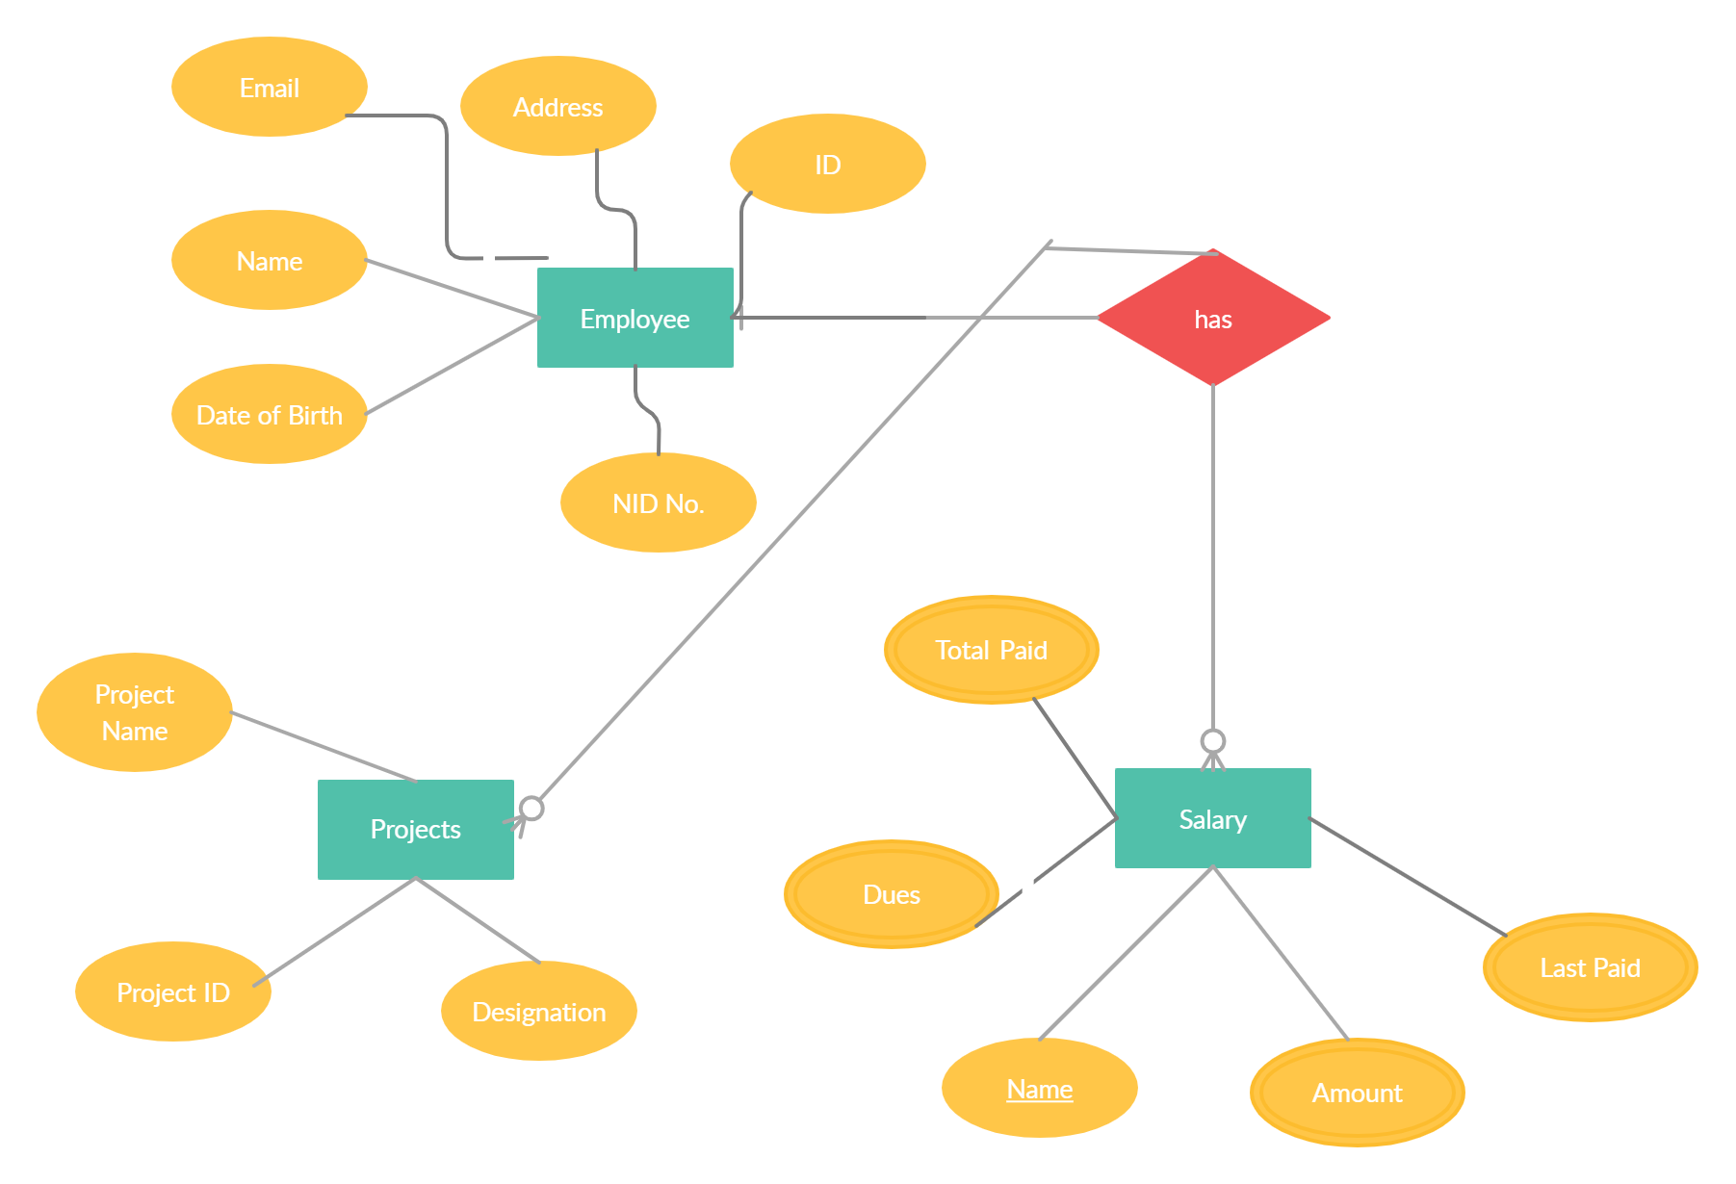

Figure 6.1: ER diagram of employee management of BLRI

**6.3 Database Tables**

A database contains one or more tables. Each table is identified by a name. Tables contain records (rows) with data. For a database of the system, we created seven database tables. The structure of the database tables are defined here

**6.3.1 Employee Information Table:**

The employee table has 8 attributes. They contain all the necessary information of the employees of BLRI. The primary key of this table is the Employee Id.

|  |  |  |  |  |  |  |  |
| --- | --- | --- | --- | --- | --- | --- | --- |
| Employee Id | Employee  Name | Date of Birth | Address | Email | NID no. | Contact No. | Designation |
|  |  |  |  |  |  |  |  |
|  |  |  |  |  |  |  |  |
|  |  |  |  |  |  |  |  |
|  |  |  |  |  |  |  |  |
|  |  |  |  |  |  |  |  |
|  |  |  |  |  |  |  |  |
|  |  |  |  |  |  |  |  |

Table 6.1: Employees Information Table

**6.3.2 Salary Information Table:**

The Salary table has 9 attributes. They contain all the necessary information of payment procedure of the employees of BLRI. The primary key of this table is the Employee Id.

|  |  |  |  |  |  |  |  |  |
| --- | --- | --- | --- | --- | --- | --- | --- | --- |
| Employee Id | Employee Name | Salary | Joining Date | Retirement  Date | Last Paid Date | Last  Payment  (TK)t | Dues | Total Paid |
|  |  |  |  |  |  |  |  |  |
|  |  |  |  |  |  |  |  |  |
|  |  |  |  |  |  |  |  |  |
|  |  |  |  |  |  |  |  |  |
|  |  |  |  |  |  |  |  |  |
|  |  |  |  |  |  |  |  |  |
|  |  |  |  |  |  |  |  |  |

Table 6.2: Salary Information Table

**6.3.3 Research Projects Information Table:**

The employee table has 5 attributes. They contain all the necessary information of all the ongoing projects of BLRI. The primary key of this table is the Project Id. The table also contains In Charge ID which is unique and also the employee id of the institute.

|  |  |  |  |  |
| --- | --- | --- | --- | --- |
| Project ID | Project Name | Project In Charge Name | Project In Charge ID | Starting Date |
|  |  |  |  |  |
|  |  |  |  |  |
|  |  |  |  |  |
|  |  |  |  |  |
|  |  |  |  |  |
|  |  |  |  |  |

Table 6.3: Research Projects Information Table

**6.3.4 Research Projects Employees Information Table:**

The employee table has 5 attributes. They contain all the necessary information of all the ongoing projects employees of BLRI. The primary key of this table is the Employee Id. The table also contains Project ID which is the project id of corresponding working project of each employees.

|  |  |  |  |  |
| --- | --- | --- | --- | --- |
| Employee ID | Employee Name | Working Project | Project ID | Project Managing Designation |
|  |  |  |  |  |
|  |  |  |  |  |
|  |  |  |  |  |
|  |  |  |  |  |
|  |  |  |  |  |
|  |  |  |  |  |

Table 6.4: Research Projects Employees Information Table

**6.3.5 Training Projects Information Table:**

The table has 5 attributes. They contain all the necessary information of all the ongoing training projects of BLRI. The primary key of this table is the Employee Id. The table also contains Project ID which is the project id of corresponding working project of each employees.

|  |  |  |  |  |  |
| --- | --- | --- | --- | --- | --- |
|  |  |  |  |  |  |
|  |  |  |  |  |  |
|  |  |  |  |  |  |
|  |  |  |  |  |  |
|  |  |  |  |  |  |
|  |  |  |  |  |  |

Table 6.5: Training Projects Information Table

**6.3.6 Trainee Information Table:**

The table has 5 attributes. They contain all the necessary information of all the ongoing training projects of BLRI. The primary key of this table is the Employee Id. The table also contains Project ID which is the project id of corresponding working project of each employees.

|  |  |  |  |  |  |  |
| --- | --- | --- | --- | --- | --- | --- |
| Trainee ID | Trainee Name | Training Project Name | Project ID | In Charge ID | Address | Contact  Number |
|  |  |  |  |  |  |  |
|  |  |  |  |  |  |  |
|  |  |  |  |  |  |  |
|  |  |  |  |  |  |  |
|  |  |  |  |  |  |  |

Table 6.6: Training Projects Information Table

**6.4 Conclusion:**

A database is a collection of interrelated data stored with a minimum of redundancy to serve many applications. Database design minimizes the artificiality embedded in using separate files. The primary objective is fast response time to inquiries, more information at low cost, control of redundancy, clarity, and ease of use, data, and program independence, privacy and security of information, etc. Nowadays a database is a must for any kind of system and organization. But Bangladesh Livestock Research Institute has not their well-enriched database. Some of the records are kept in the traditional file system. So we focused on designing a database for the organization. This database schema development does not require a lot of money, but the users’ willingness to do it. If this database is developed by the authority it will help the system a lot as well as building a good website of them.